**SEIS 610 -03 –Software Engineering:**

**Macro Meal Picker**

**by:**

**Uma Krishnaraju**

**Angela Holden**

**Brenda Canales**

**Anil Kumar Reddy**

**INCEPTION**

|  |  |  |
| --- | --- | --- |
| **Version** | **Status** | **Version Date** |
| **1.0** | **Draft** |  |

1. **Project Vision**

The website Macro Meal Picker guides users with daily nutrition meal options for a provided dietary need. Application would give an interface to pick the percentage of macros and calories needed per meal or week; In addition to this the interface will have the ability to opt the cuisine and ingredients for the appropriate macros and calories chosen. The Indented Inputs from the user would be the age, weight and height.

1. **Project Boundaries**

|  |  |
| --- | --- |
| a. | This would be a web-based application written in Java, Java script, HTML and CSS. |
| b. | This Application would be compatible only with IE and google chrome browsers and browsers on smart phones. This application will not be compatible with Firefox or any other browsers and not intended to use as a mobile App. |
| c. | The nutrition values calculations are based on ingredients commonly sold in US local stores. |
| d. | This tool would just highlight the dairy or nuts used in the meal but not any other allergy triggering information. |
| e. | This tool would not provide options for in person appointment with the nutritionists for customizing meal plan. |
| f. | Data base and website will be hosted on cloud; hence the website might not be functional due to any down time with cloud infra structure. |
| g. | Users can save their meal plan max for a week. |
| h. | Website could handle only 10,000 users at a time. |

**g. limitation is fitness tracking**

1. **Requirements**

|  |  |
| --- | --- |
| a. | As an end user, I would like to find meal options based on the indented input of macro percentage, ingredients, cuisine and calories per meal (20 Apples) |
| b | As an end user, I would like to find meal options based on the indented input of macro percentage, ingredients, cuisine and calories per week (20 Apples) |
| b. | As an end user, I would like to set a target weight so I can find some meal options to help me get to the target weight.(10 Apples) |
| d. | As an end user I would like to select my favorite ingredients so the app can suggest meals relevant to the selected ingredients. (10 Apples) |
| e. | As an end user, I would like to review the final selected options to retrieve the meal plans (5 Apples) |
| f. | As a end user, I would like to save may meal preferences to be saved in the system (5 Apples) |
| g. |  |

1. **Business Case and Initial Cost Estimate (20 points)**

|  |  |
| --- | --- |
| a. | Project has a total of 70 Apples. We believe each tomato is worth 2 hours of labor. We believe our hourly rate to be at $80.00 per hour, therefore cost of labor for the project will be $5,600. $150.00 |
| b. | The project will only need a PC or two with Java. Maximum tool cost $1000.00. |
| c. | Project cost may end up high for hosting the website and database on cloud. Need DO $$ |
| d | There is wide range of similar web sites in the market that would potentially impact and has risks to our initiative |
| d. | Despite of many business risks and high cost estimate, we have huge potential cost benefit to address the user needs in a unique way and sustainable growth by building new features and functionalities to the application - like fitness tracking |
|  |  |

1. **Identify Risks. (15 points)**

|  |  |
| --- | --- |
| a. | No experience calling java program within web-based application |
| b. | Limited amount of nutritionist knowledge. |
| c. | Not sure how to calculate the nutrition values and calorie formulas |
| d. | Some of the team members would need training on SQL and database programming. |
| e. | No experience with food processing like calculating the nutrition values and not experienced with the scientific chemical names. |
|  |  |

1. **Candidate Architecture (5 points)**

Server less Architecture

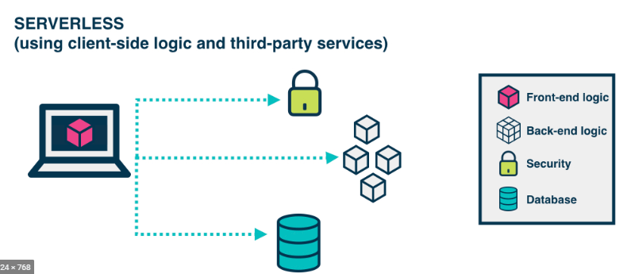

1. **Non-functional requirements (Often called FURPS in Rational Unified Process)**

|  |  |
| --- | --- |
| a. | Sensitive information would be encrypted when data is at rest and as well as on the GUI. |
| b. | Performance- |
| c. | Usability- |
| d. | Reliability- |
| e | Supportability/Scalability- |
|  |  |

1. **Glossary.**

|  |  |
| --- | --- |
| Daily Value | The amount of a nutrient (in grams, milligrams or micro grams) recommended per day for Americans 4years or older age. The nutrition fact labels lists the daily value for base 2000 calories daily diet. |
| Essential Nutrients | A vitamin, mineral, fatty acid or amino acid required for normal body functioning. |
| GUI | Graphical user interface. Interface used by users to enter and access information |
| End User | People who are performing actions or using the application. |